* Remove the word Analytics on the menu bar and add the subscription Plan and user count
* Change the word Sub Customers to Invite User and make it for only account owners/ Admins can only have access
* Move the help page down to where change password and change password up where Help is
* make the profile picture active and change when a user adds a photo on the my accounts page
* Add a dark screen option and icon by the top right profile box - When user clicks dark screen all pages go dark screen

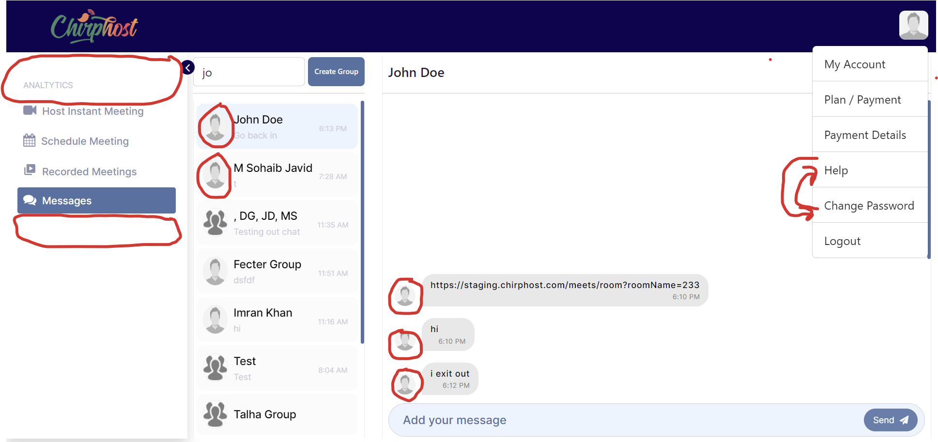

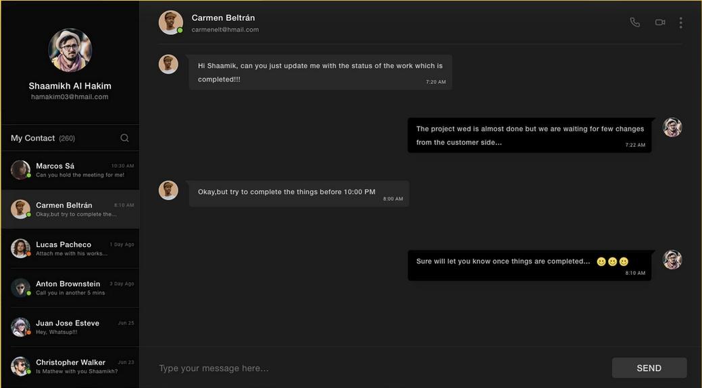

Add a new Section below Sub Customers to Label it Mass invite Users

Change the word Sub Customers in the first section to Invite User

Add instructions that says: Please download the template and fill out the fields in the spreadsheet to upload and mass load new account users.

Change the word Sub Customers in the first section to Invite User

Create a excel template with the field necessary to create a new user account for inviting new account users.

Create a invitaion email that gets sent to the new user with a link in the email for them to create their password and have access to their new account.

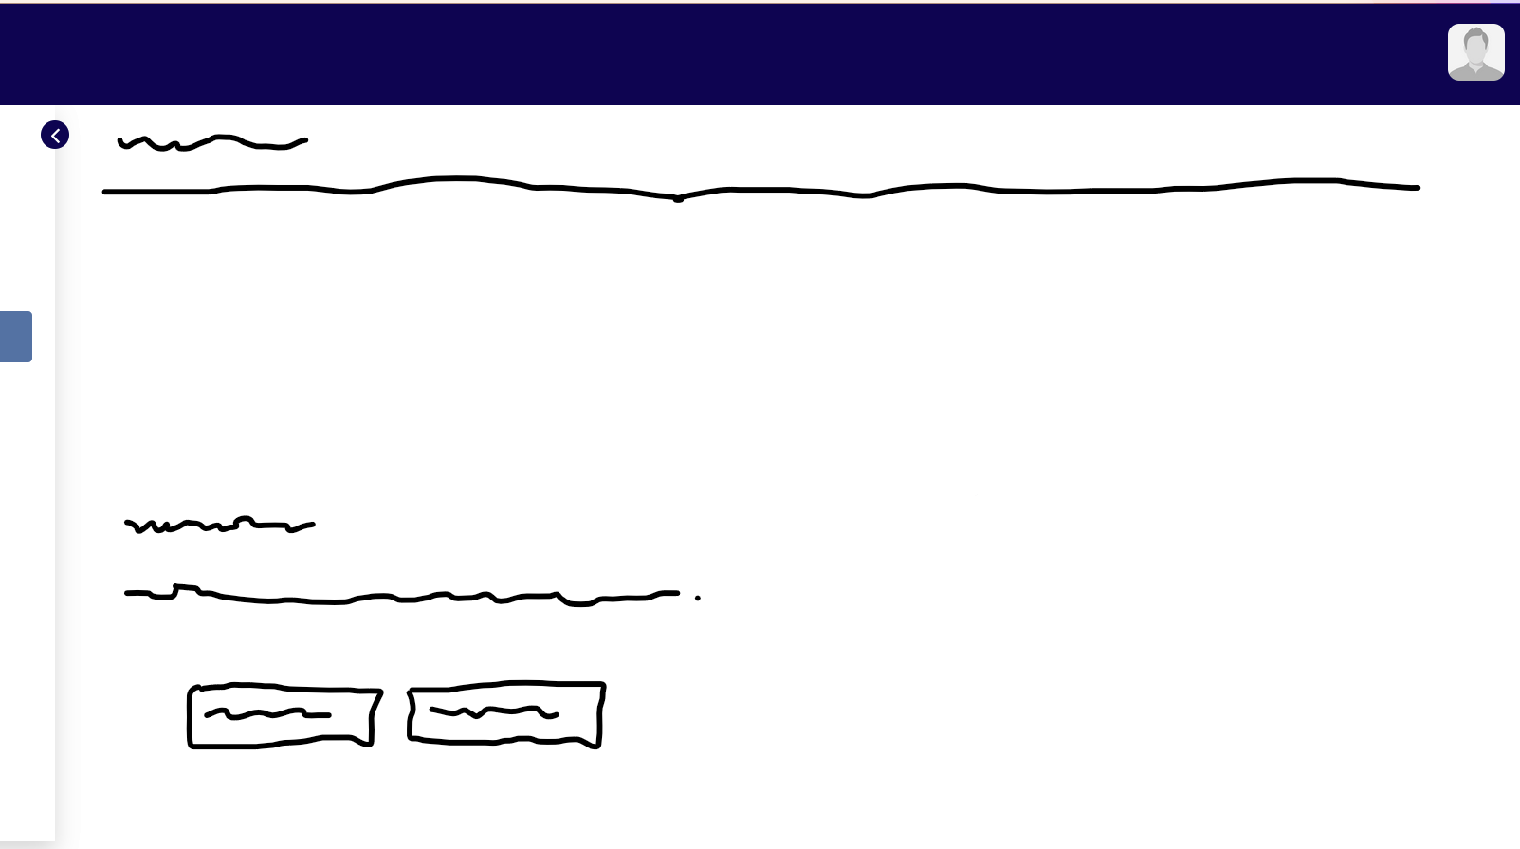

Add the subscription info to the menu

Change the field Company Name to : Company Name/Tagline

Make a larger profile circle and center it in the blue box and change to full name and Company Name/ Tagline

Fix the photo upload to word and also automaically upload the photo to be shown on the Meeting page when the user selects the option not to show Face an the call

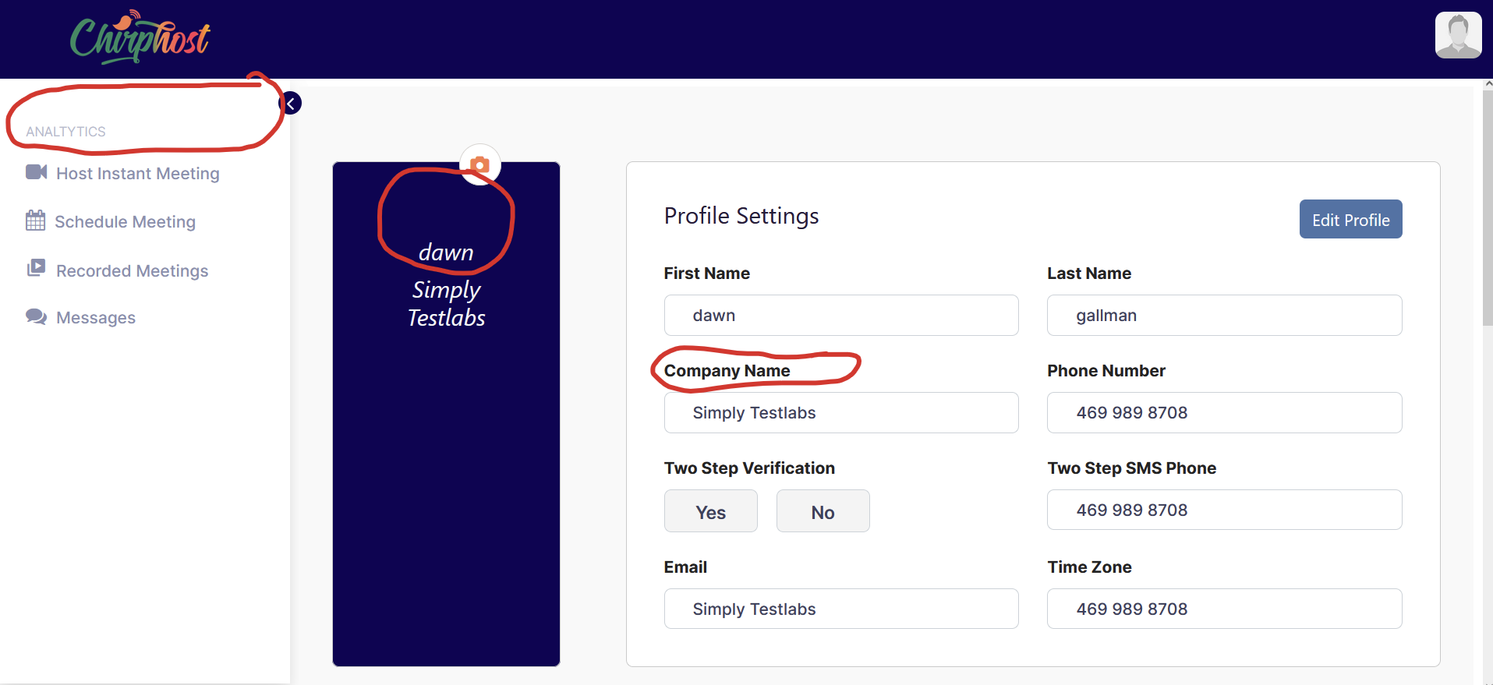

* Make the Profile Circle a Larger circle
* Fix the photo upload to word and also automatically upload the photo to be shown on the video calling page when the user selects the option not to show Face an the call
* Add labels on all the icon buttons on all the menu bar
* add notification # on the chat icon

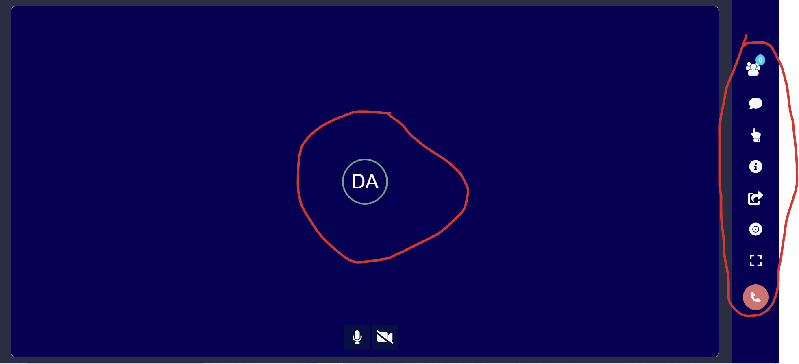

* Change the the view that a participants see when someone is screen sharing:
* Change Screen share to show Entire Screen no menu bar with no visual of the presenter or any others in the call, Just full edged screen. No rounded edges

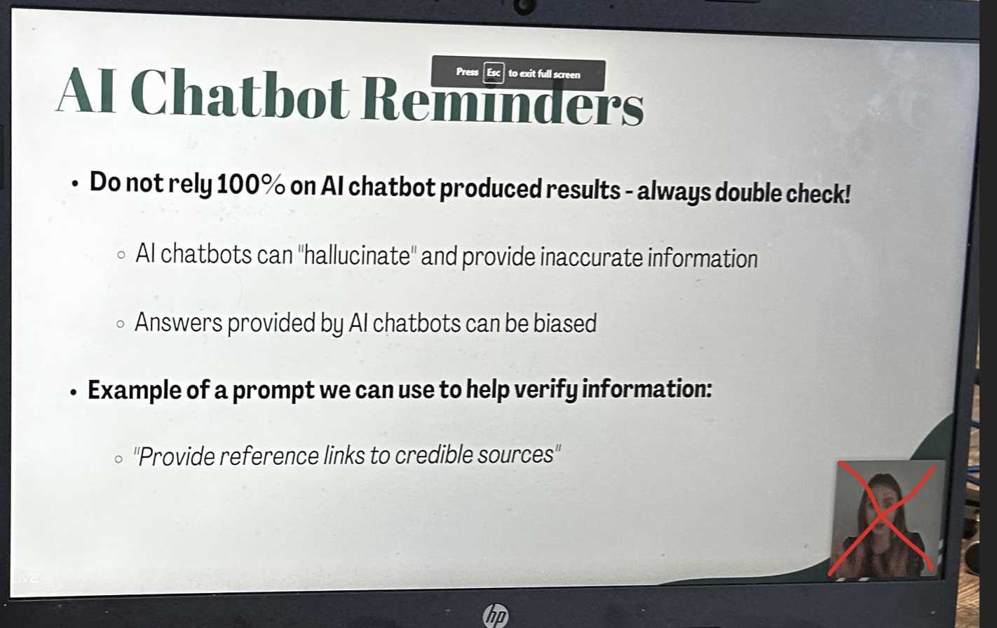

Please remove this message popup

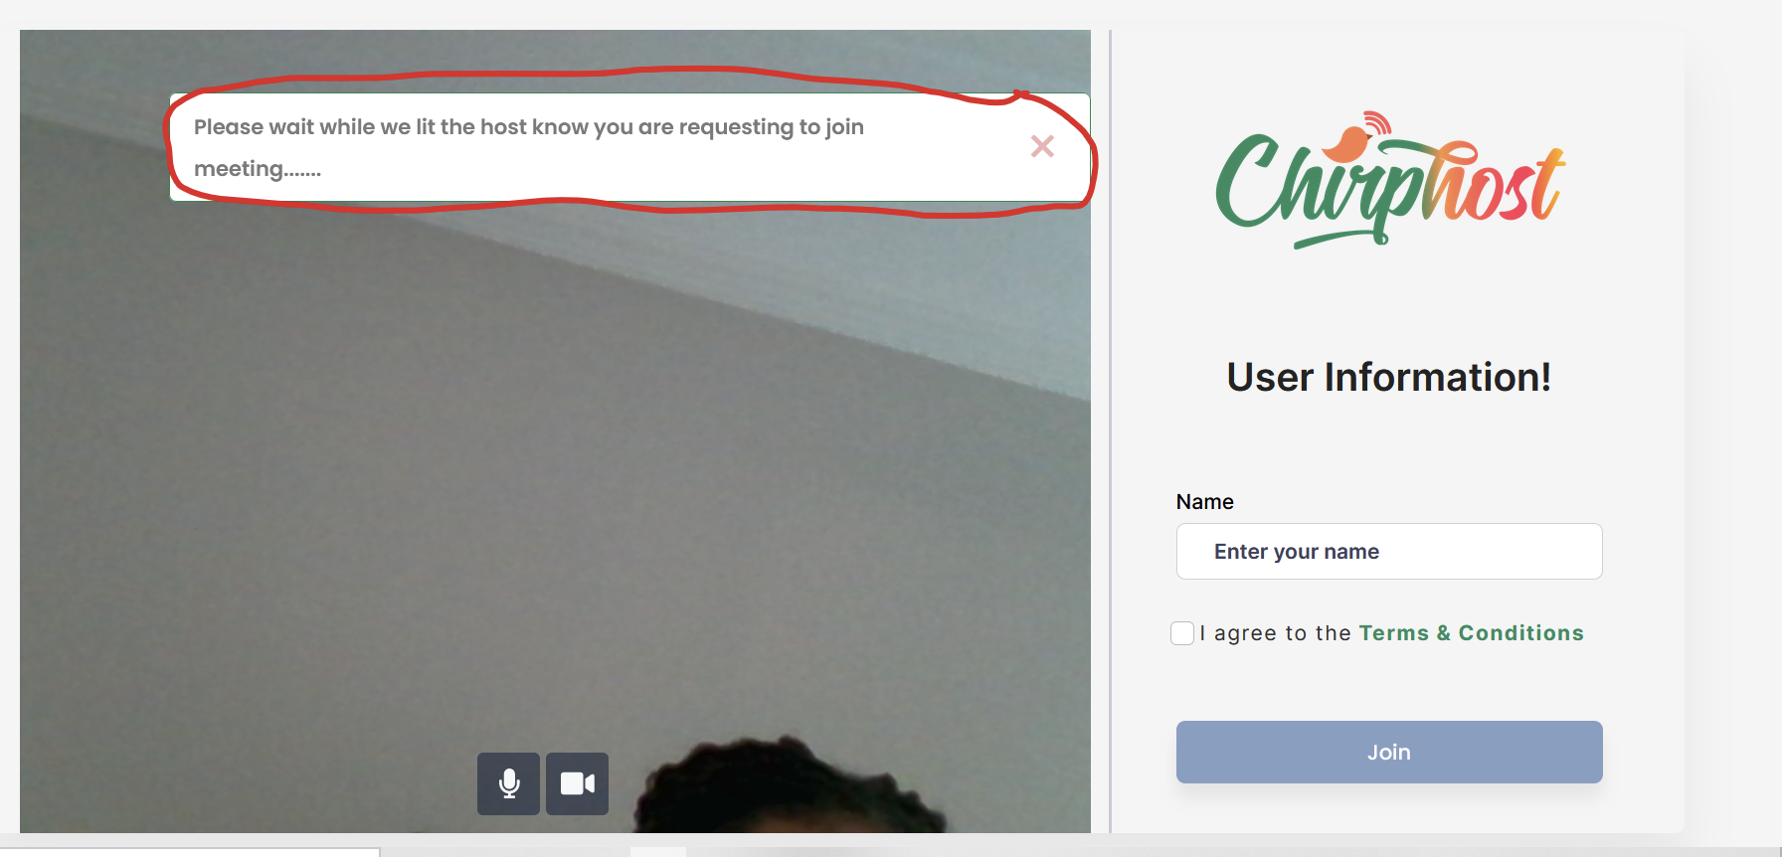

Add subject Field the Ticket page:

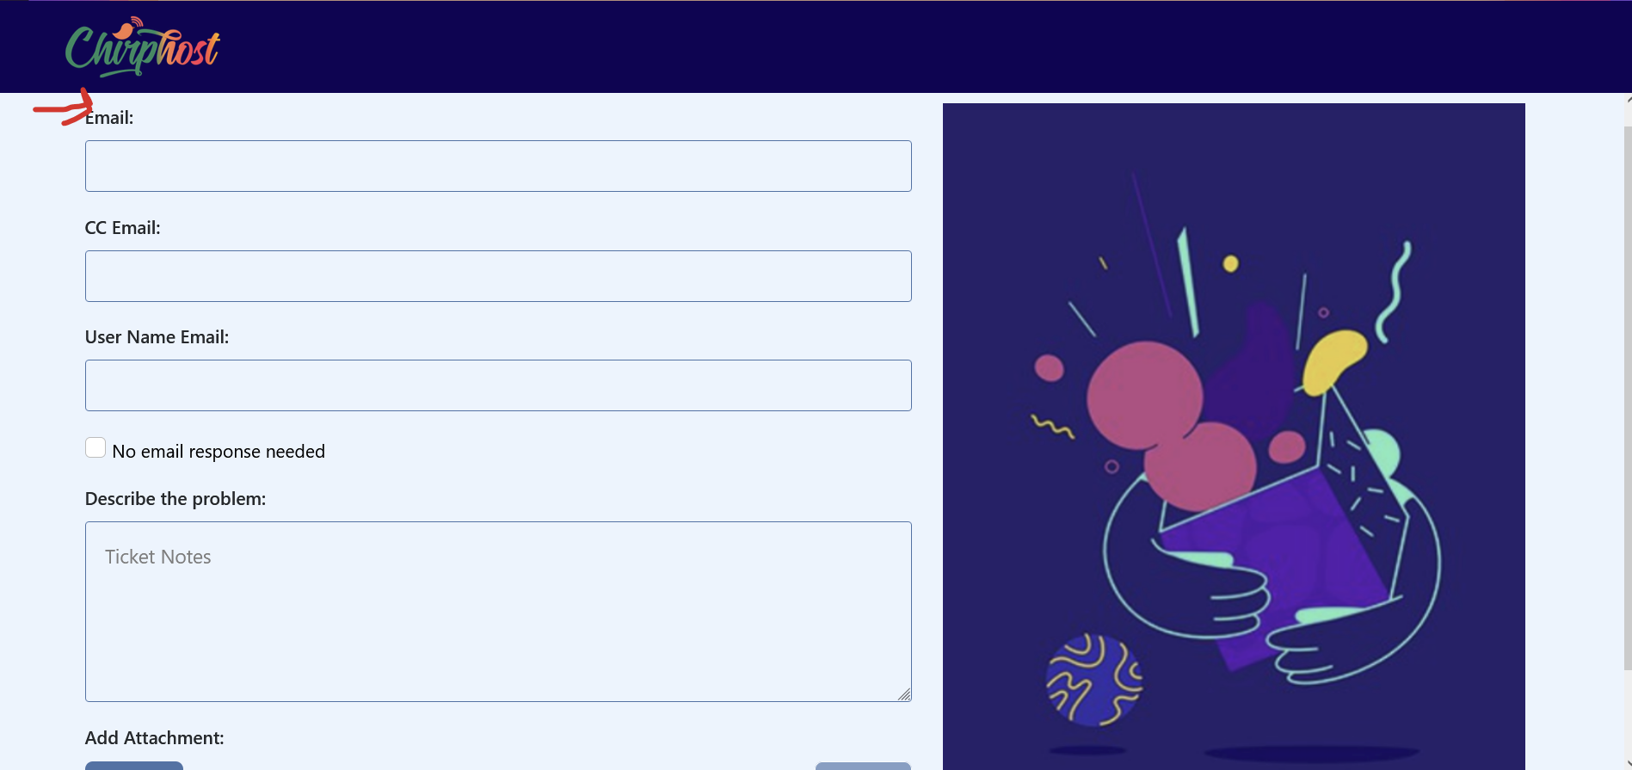

Make Chirphost application downloadable for desktop. Please note that you dont have to make mobile just desktop. I found a third party company that will wrap the application and submit approval to google and apple play stores. As soon as we deploy the application the the live domain Chirphost.com they can get started.

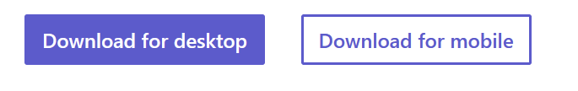

Complete recording page and process on meeting page:

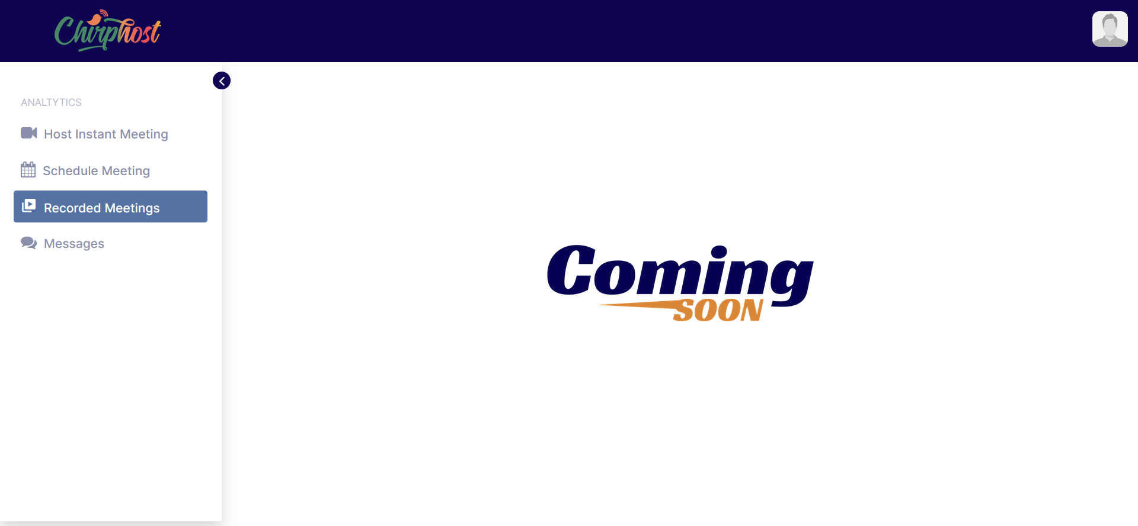

Keep Development on Staging.chirphost.com and Move to live Production on: Chirphost.com

Add SSL security

